Title : online retail_Segment

**NAME : ALEEZA**

**INTRODUCTION:**

**OBJECTIVES:**

* **Understand data mining**
* **Run queries in my sql for data mining**
* **Find important insights from data to get more reliable data**
* **Implement different techniques in large scale for good result**

**OVERVIEW:**

It is a data about a online retail segment .in this dataset there are 8 attributes and approximately 13116 rows.

* **InvoiceNo** Unique transactionidentifier.
* **StockCode:** Unique product code.
* **Description:** Product description.
* **Quantity:** Quantity sold per transaction.

**·InvoiceDate:** Transaction date and time.

·**Unit Price:** Price per product.

·**CustomerID:** Unique customer identifier.

**Importance of Segmentation:**

Segmentation play a very vital role in any business .it is use to identify the following;

Distinguish between daily, occasional customers help to tailor strategies effectively.

Focus on high-frequency customers with loyalty programs.

Enable personalize promotion to different groups.

Identify trends and patterns in product sales to make informed business decisions and adapt to market changes.

Try better decision making and improve customer statisfication.

**MRTHODOLOGY:**

**Data preparation:**

* **Cleaning : Adress missing values and remove duplicates.**
* **Transformation: convert data formats and aggregate where nessacery .**

**Sql Queries:**

**Question # 1:**

·        What is the distribution of order values across all customers in the dataset?

In this question we are ask to perform these queries.

• **Calculate the total order value** for each customer.

• **Examine how these values are spread out** (e.g., are there a few customers with very high order values, or is the distribution relatively even?).

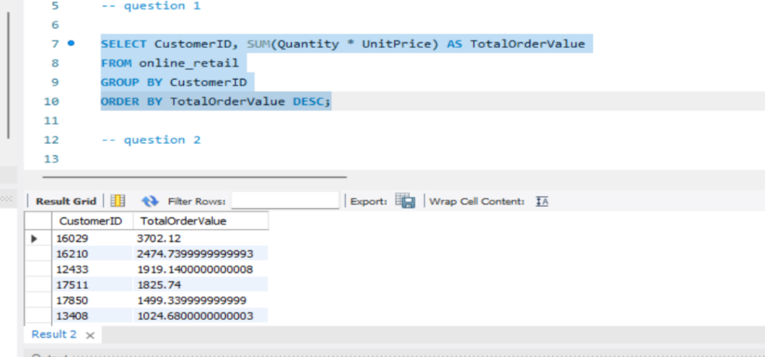

After running above query the sum() function add Quantity and unitprice as total ordervalues and showed me in a decreasing order. Because of order by dec clause.

Question # 2:

How many unique products has each customer purchased?

We will to find out :

Whether customers are repeat buyers of the same products or if they explore a variety of offerings

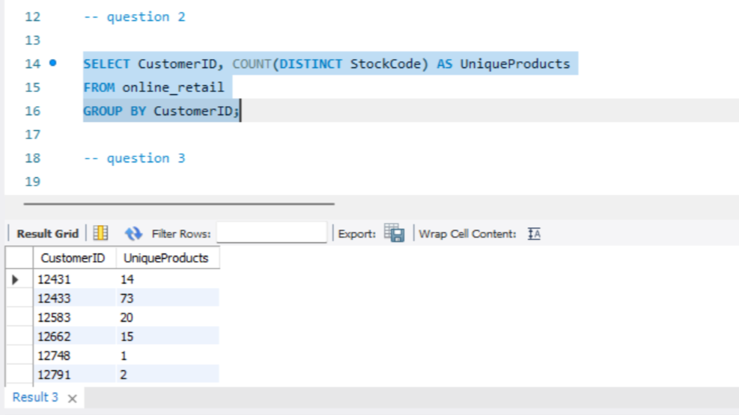

Question # 3

·        Which customers have only made a single purchase from the company?

• which customers are making their first purchase.

• Understand if customers are returning after their initial purchase.

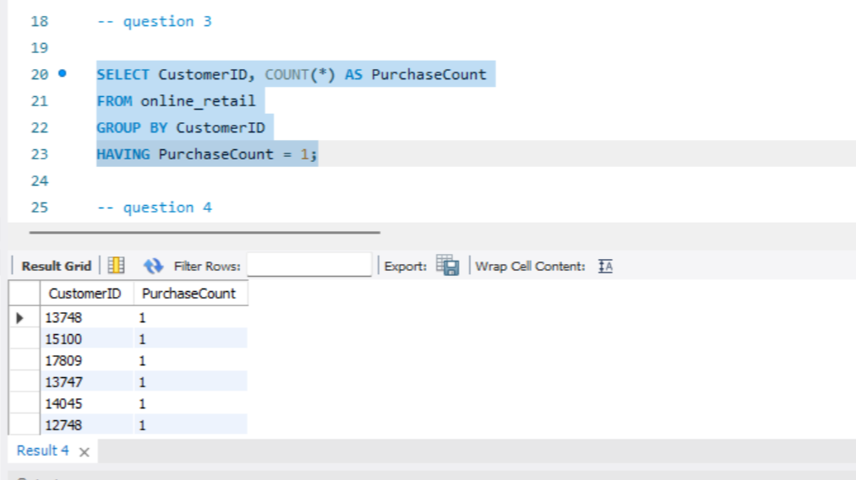

Question # 4 :

·        Which products are most commonly purchased together by customers in the dataset?

• Identify products that can be bundled or recommended together.

• Gain insights into customer shopping patterns and preferences

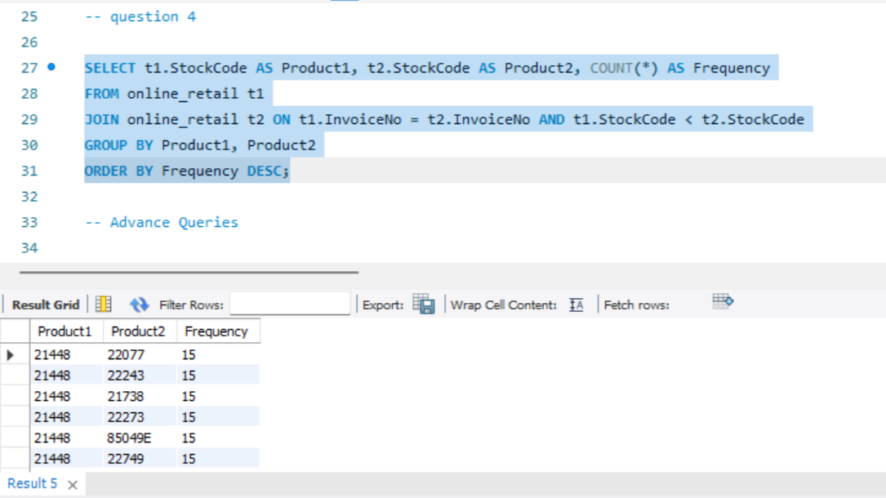

Advance Queries:

Question # 1:

**1.      Customer Segmentation by Purchase Frequency**

Group customers into segments based on their purchase frequency, such as high, medium, and low frequency customers.

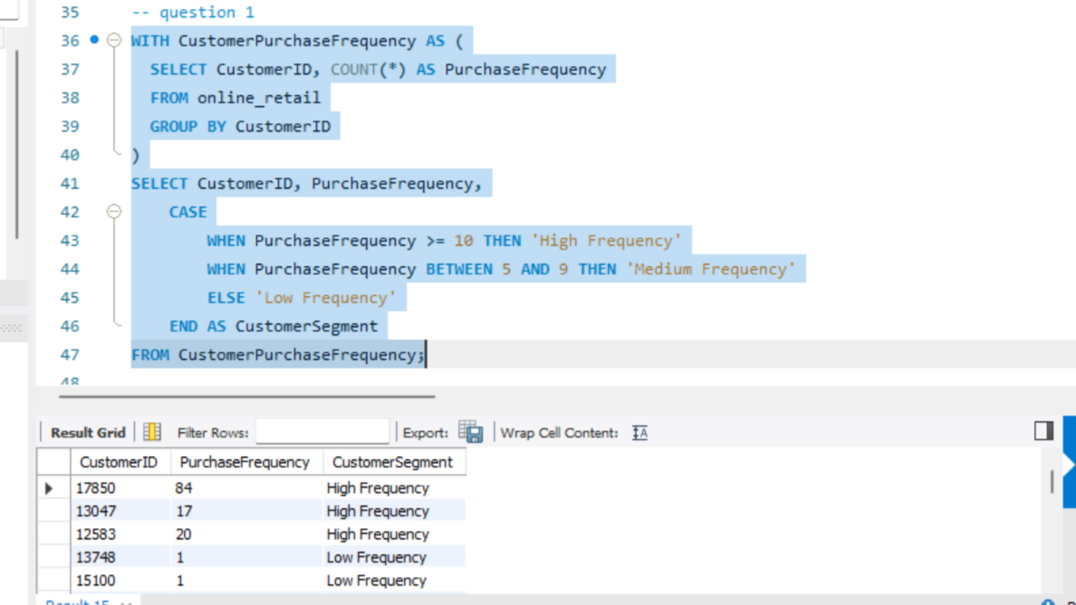

Question # 2:

**2. Average Order Value by Country**

Calculate the average order value for each country to identify where your most valuable customers are located.

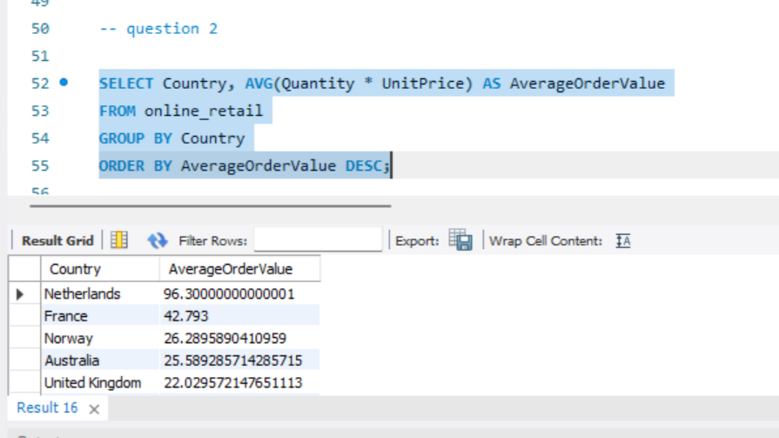

question # 3:

**3. Customer Churn Analysis**

 Identify customers who haven't made a purchase in a specific period (e.g., last 6 months) to assess churn.

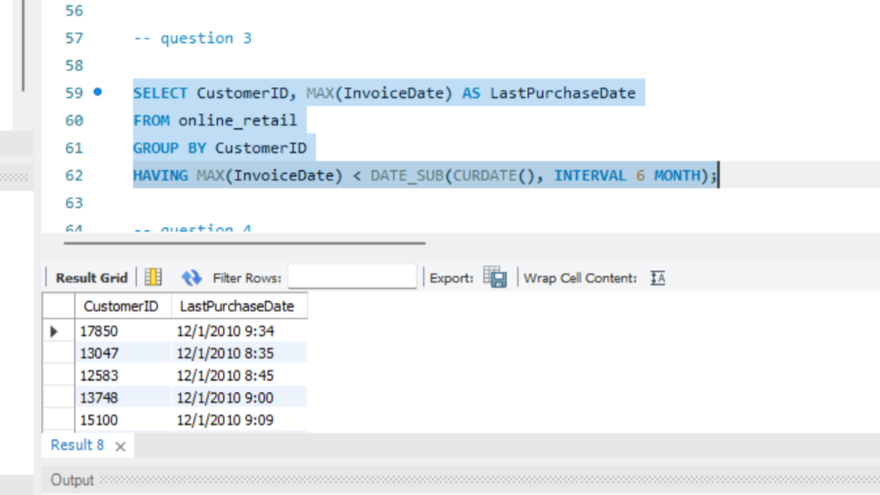

Question # 4:

**4. Product Affinity Analysis**

Determine which products are often purchased together by calculating the correlation between product purchases.

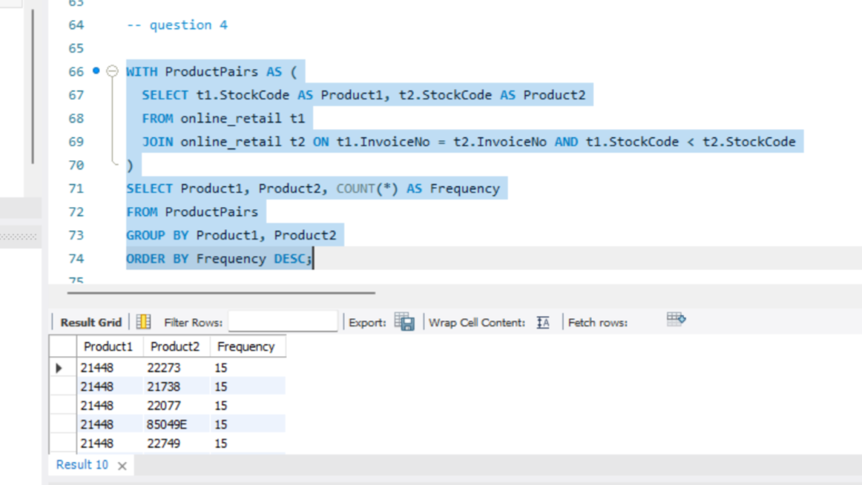

Question # 5:

**5. Time-based Analysis**

  Explore trends in customer behavior over time, such as monthly or quarterly sales patterns.sssss

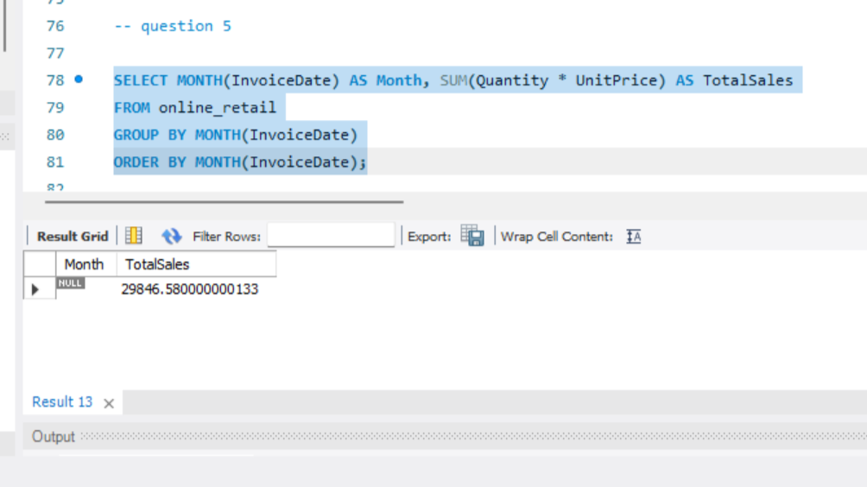

6. Conclusion:

Effective segmentation using this dataset has provided valuable insights into customer behavior and purchasing patterns. By understanding customer segments and market trends, the business can tailor its strategies to enhance customer engagement, optimize product offerings, and improve overall performance.

Recommendations:

• Implement targeted marketing campaigns based on customer segments.

• Focus on retaining high-value customers and addressing churn.

• Optimize inventory and promotions based on product affinity and sales trends.

**References:**

* Dataset Source: [LMS ]
* SQL Tools Used: [e.g., MySQL Workbench]